**8-BIT DIVISION**  
  
 **EXP NO: 4**  
  
**AIM:**

To write an assembly language program to implement 8-bit division using 8085 processor.  
  
  
**ALGORITHM:**

1)      Start the program by loading a register pair with the address of memory location.  
2)      Move the data to a register.  
3)      Get the second data and load it into the accumulator.  
4)      Subtract the two register contents.  
5)      Increment the value of the carry.  
6)      Check whether the repeated subtraction is over.  
7)      Store the value of quotient and the reminder in the memory location.  
8)      Halt.  
  
  
 **PROGRAM:**  
  
LDA 8501  
  
MOV B, A  
  
LDA 8500  
  
MVI C,00

LOOP:   CMP B  
  
JC LOOP1  
  
SUB B  
  
 INR C  
  
JMP LOOP    
  
LOOP1:  STA 8502  
  
MOV A, C  
  
STA 8503  
  
 RST 1

**INPUT:**

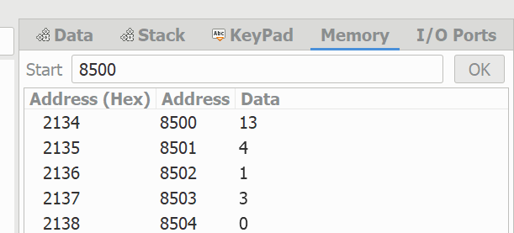  
  
  
  
  
  
  
  
  
**OUTPUT:**

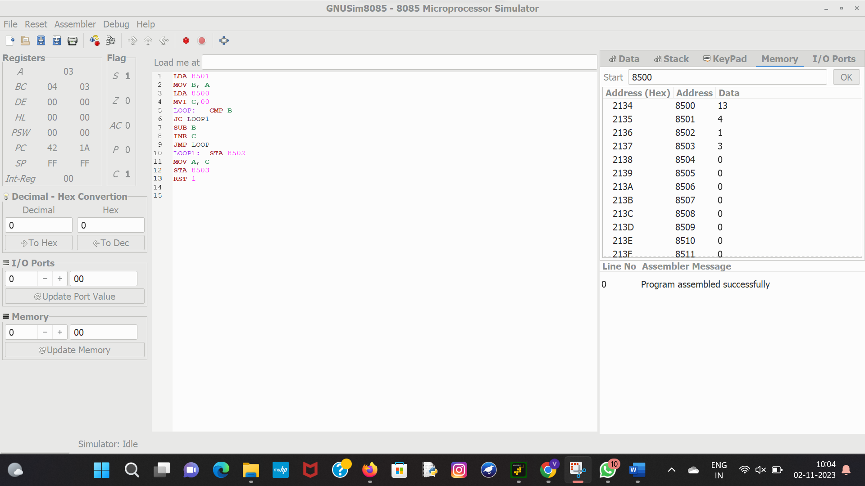  
  
  
   
  
**RESULT:** Thus the program was executed successfully using 8085 processor simulator.